eLeap Development Request (dated 16/10/2015)

#1 – Missing New Machine button on initial screen display when database is empty (V1.5.9.7)

2.1 Store > Scale Group
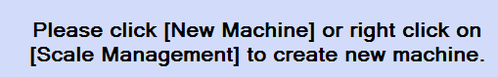

Should have a New Machine button like in New Department as below.

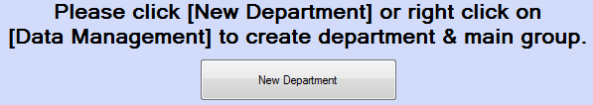

#2 – Scale Status screen not refresh after Update (V1.5.9.7)

When click Update button, the screen is not refreshed after updating is completed (pulling the diagnostic file). Require to maneuver to other screen and back again to refresh it.

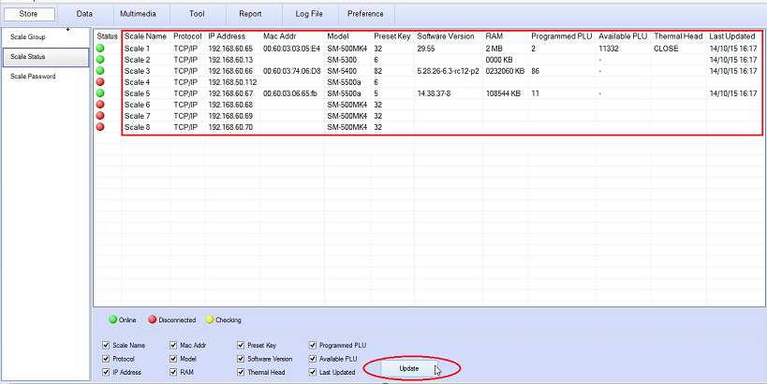

#3 – Scale Status screen not refresh after Update (V1.5.9.7)

After setting password, select [Clear All] follow by set new password and click [Save], Pop-up [Saved] dialogue box appear before selecting [YES] / [NO] from [Do you want override existing password] dialogue box.

The correct sequence should be reversed.

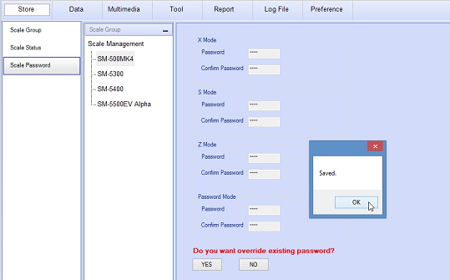

#4 – Wrong pop-up dialogue message (V1.5.9.7)

4.1 When [Send to] > [Cancel], dialogue box ‘Update Complete’ appears. Please change the message to ‘Cancelled’

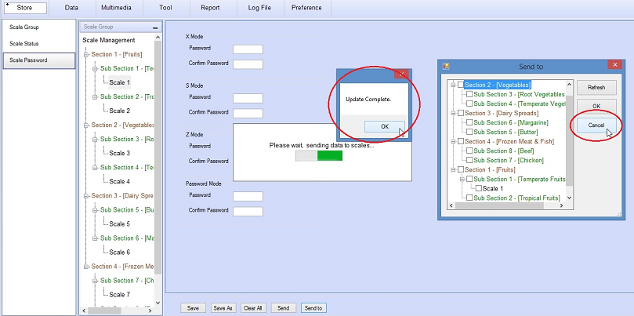

4.2 Change all pop-up dialogue message ‘Update Complete’ to ‘Update Completed’.

#5 – Data Mapping on Map Barcode Flag unable to edit and save ((V1.5.9.1)

DATA MAPPING – editing on Item Code does not save change, only way is to delete it and to recreate new mapping.

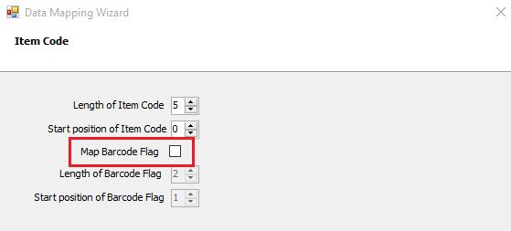

#6 – Extended Text option need to restart eLeap (V1.5.9.1)

Preference > Extended text
When check the Extended Text box, need to restart eLeap to take effect. Uncheck did not need to do so.

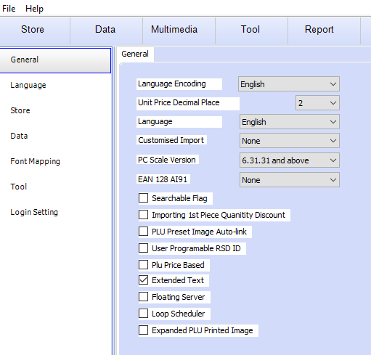

Extended Text Box
